**KSETRAJIVA**

**-*>REVIEWS FROM THE FARMERS ABOUT THE LOSE OF AGRICULTURAL CROPS DAMAGED FROM THE WILD ANIMALS IN THEIR AGRICULTURAL LAND.***

**QUESTIONS:**

The issue of wild animals, such as elephants, wild boars, and deer, is causing significant challenges for farmers globally. These animals migrate into nearby agricultural fields in search of food, leading to extensive damage to crops through consumption and trampling.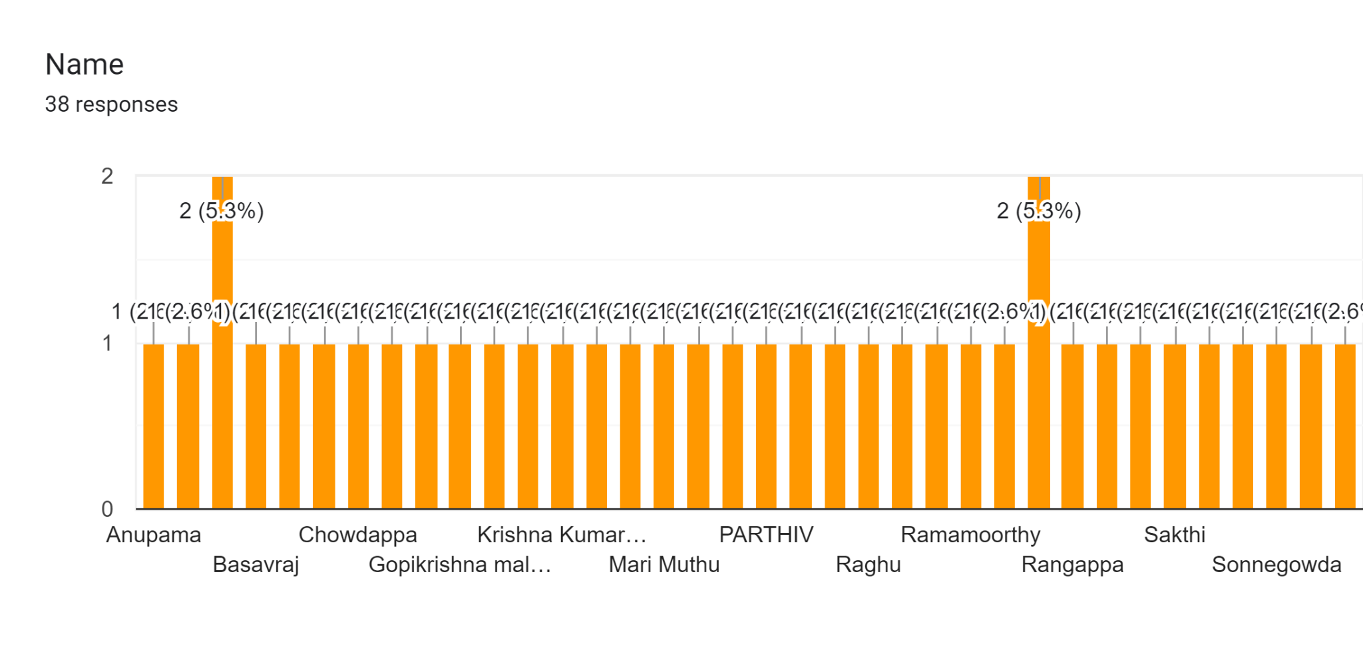

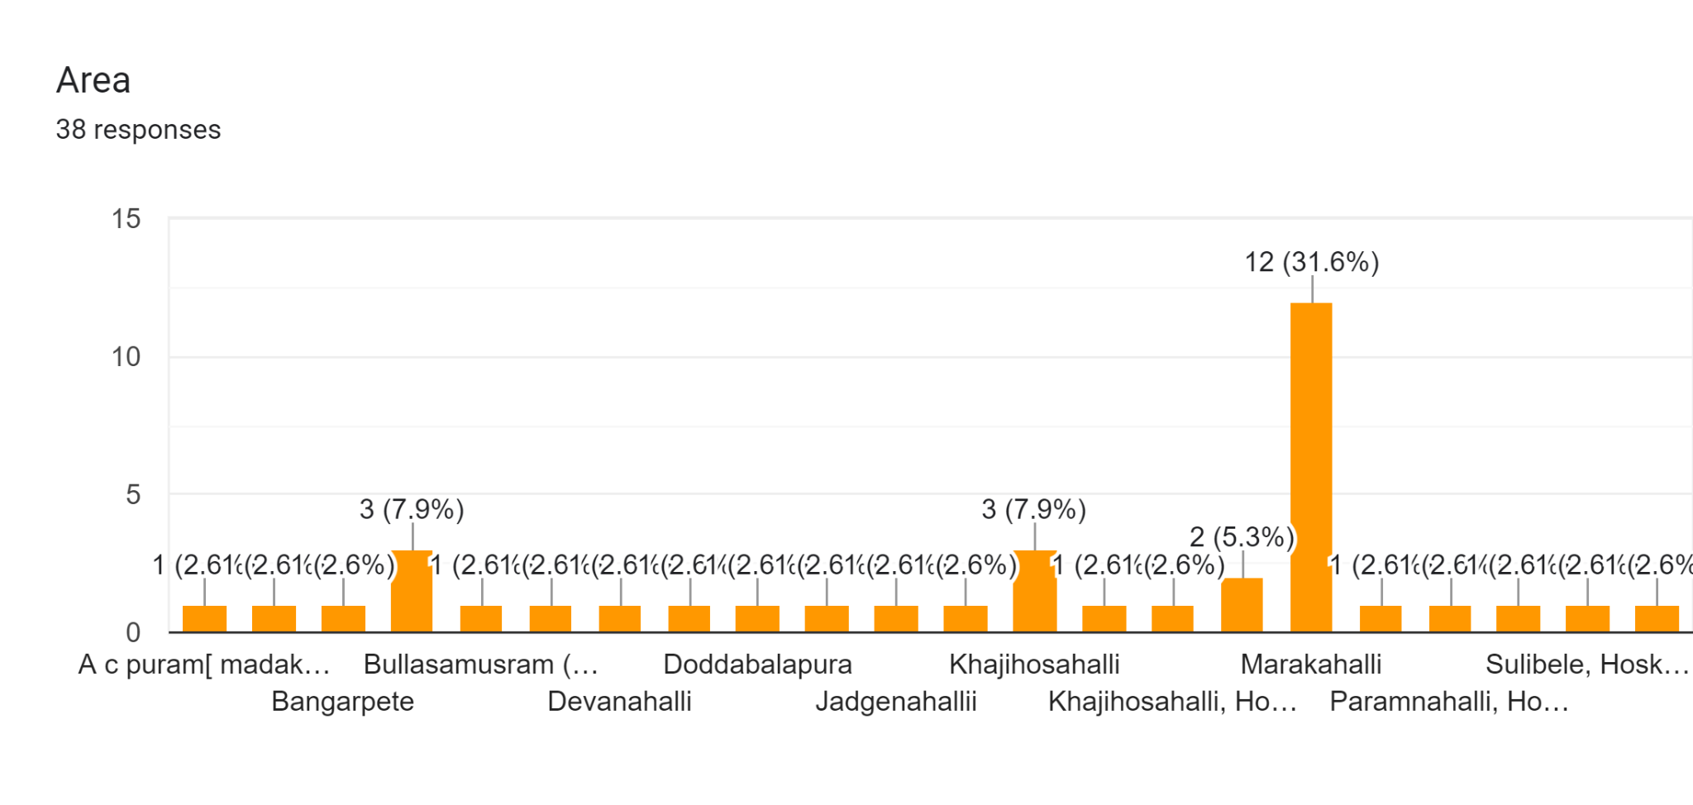

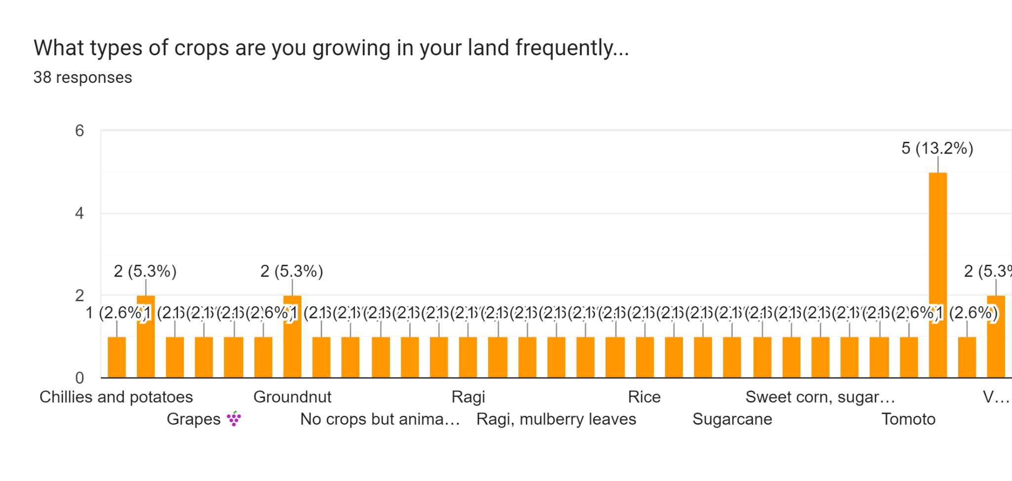

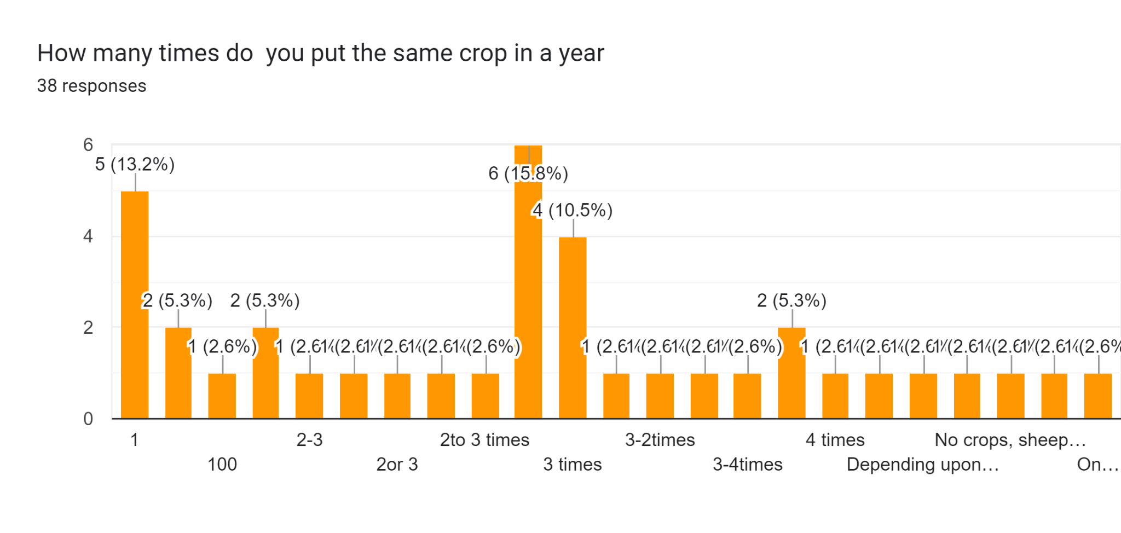

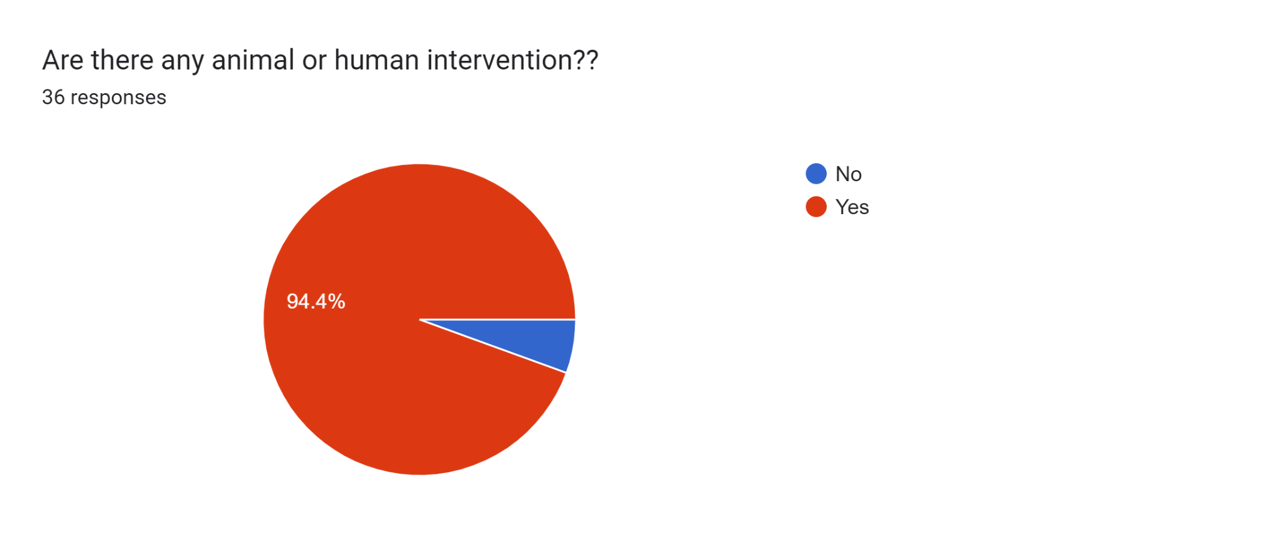

**Which types of animals attack your crop each time(38 responses)**

Bears

Bear

Deers and bears

Insects,bettles,fox ,peacock

Pig 🐷,fox 🦊

Deer, peacock, wild pig,birds

No animal issues

Pigs and bear

Pigs

Sheep and Pigs

Sheep and Pigs and rats

Monkey, bear

Pig, birds, domestic animals

Wild Pig

Deer

Bats and birds

Peacock, deer

Dogs

Deer , wildpigs

Monkey, snake

Fox rat monkey

Monkey, snake, forestcat

Pig 🐖,fox 🦊

Fox 🦊, pig 🐷

Monkey 🐵

Forest cat😺, monkey 🐒

Fox🦊,pig 🐖

Pig 🐖, monkey 🐒

Birds 🐦

Fox 🦊, pig 🐖, monkey 🐒

Pigs and rabits

Rabbits

No

Wild pig,Deer

Wild pig,deers

Cat

Elephant,Rats

Rinoserious

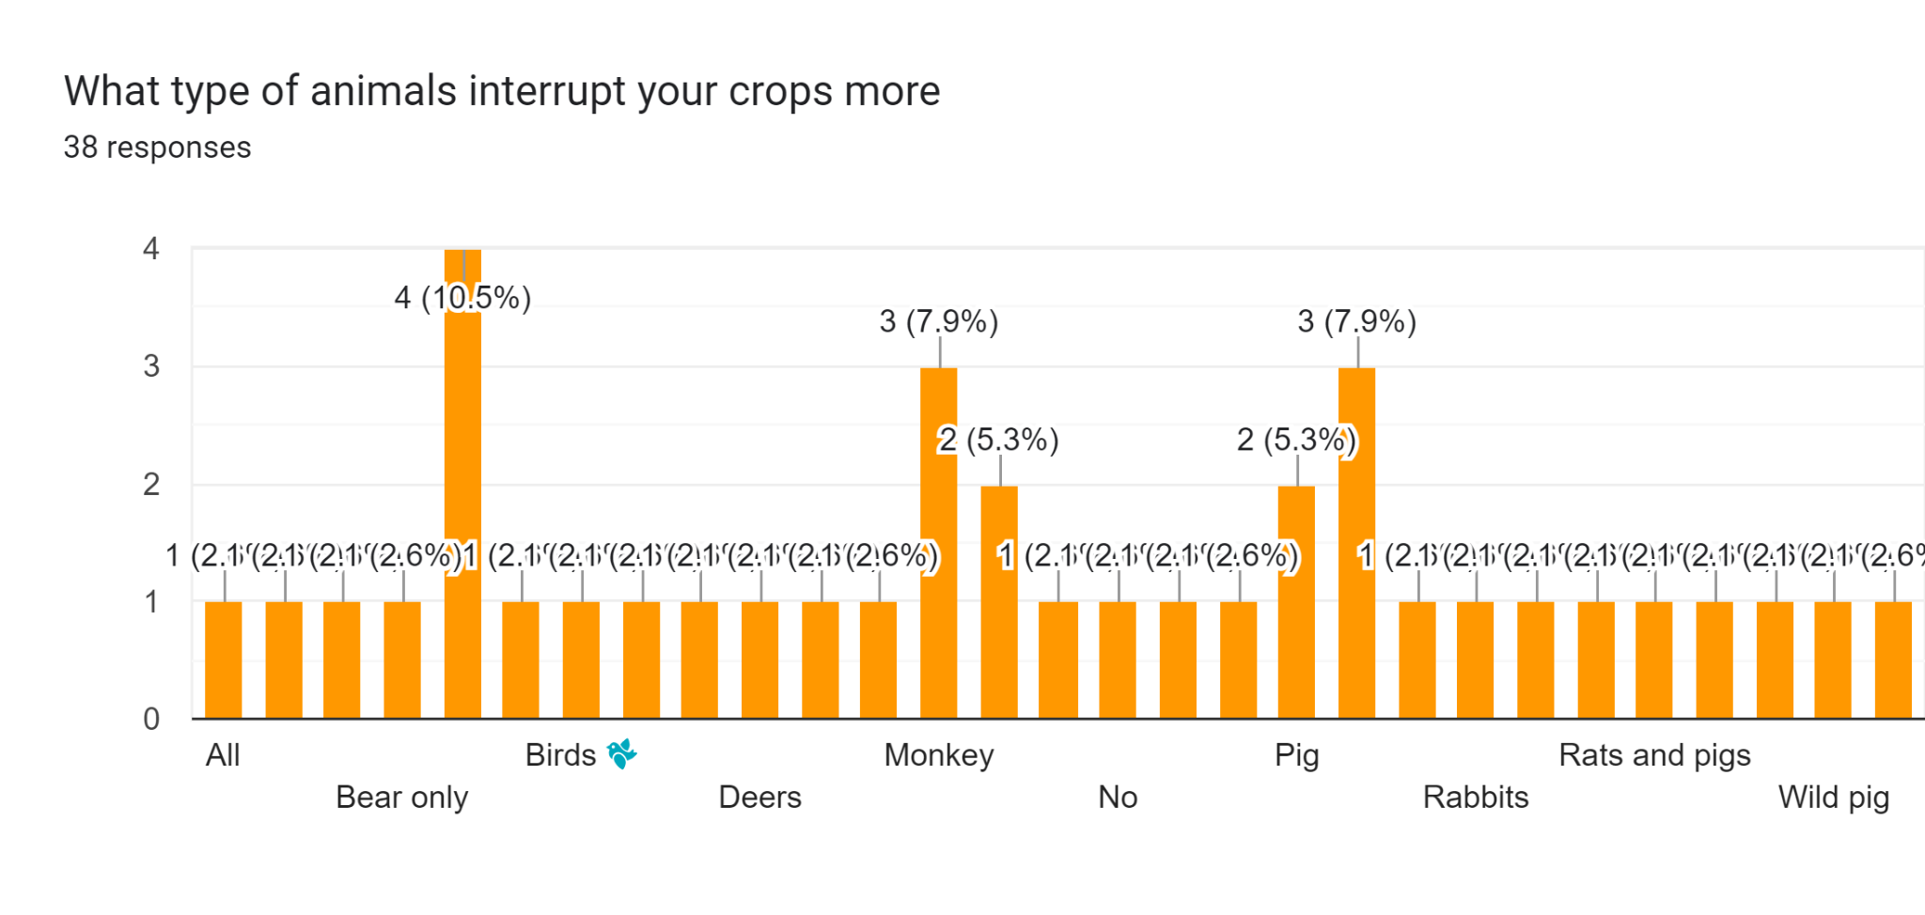

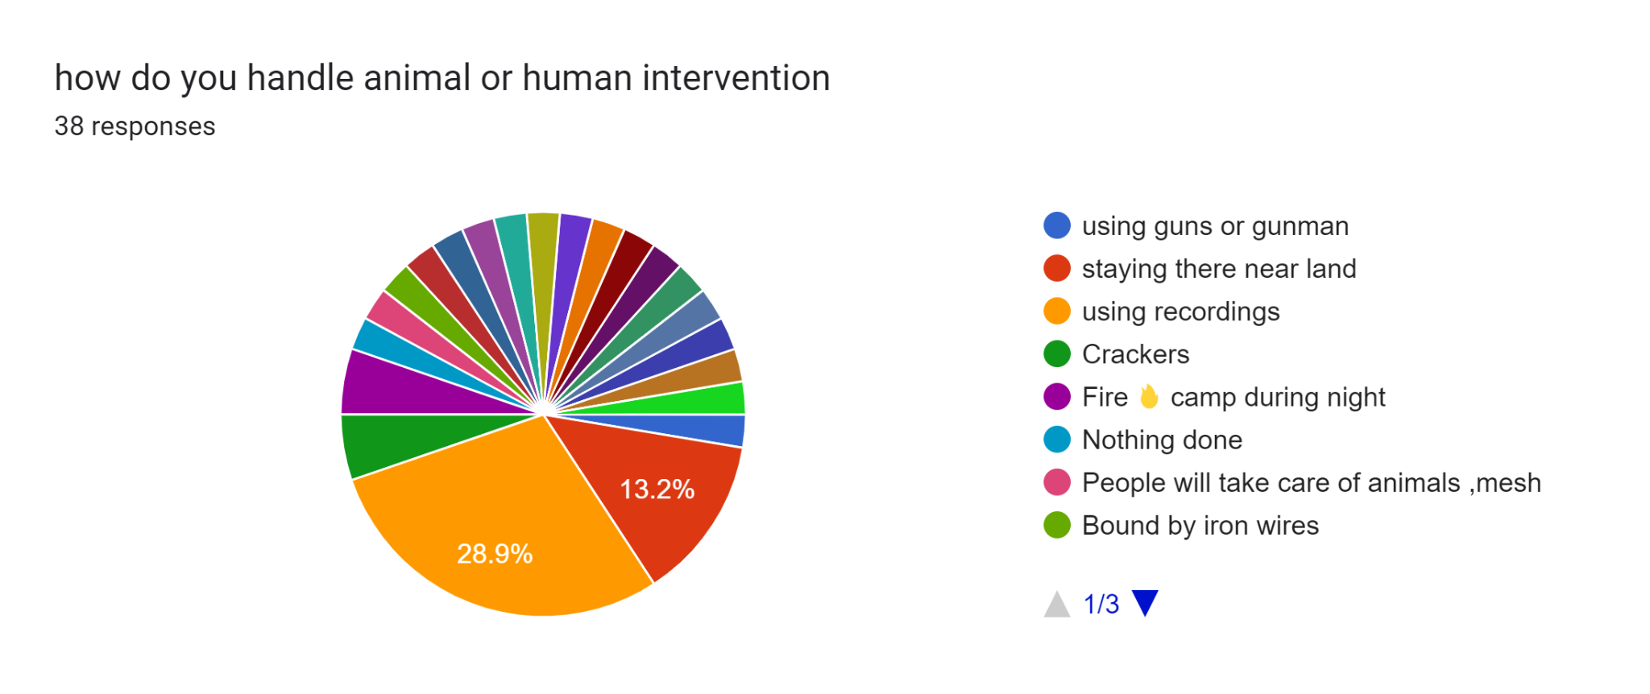

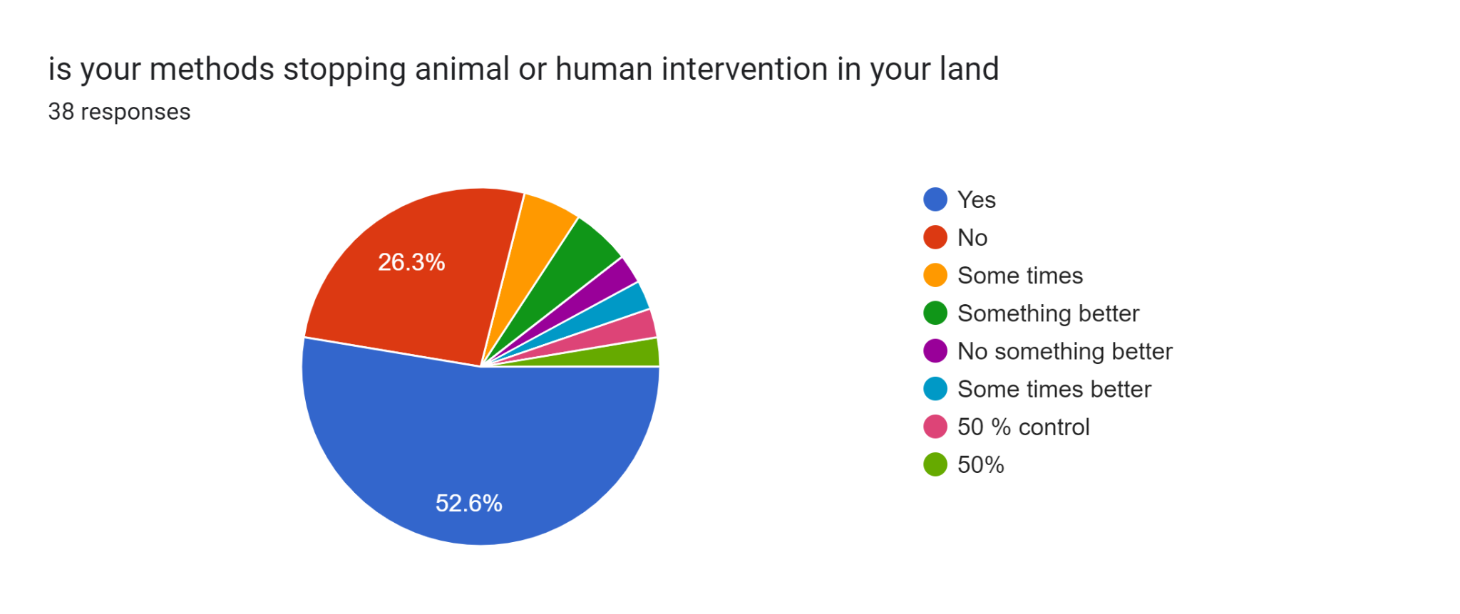

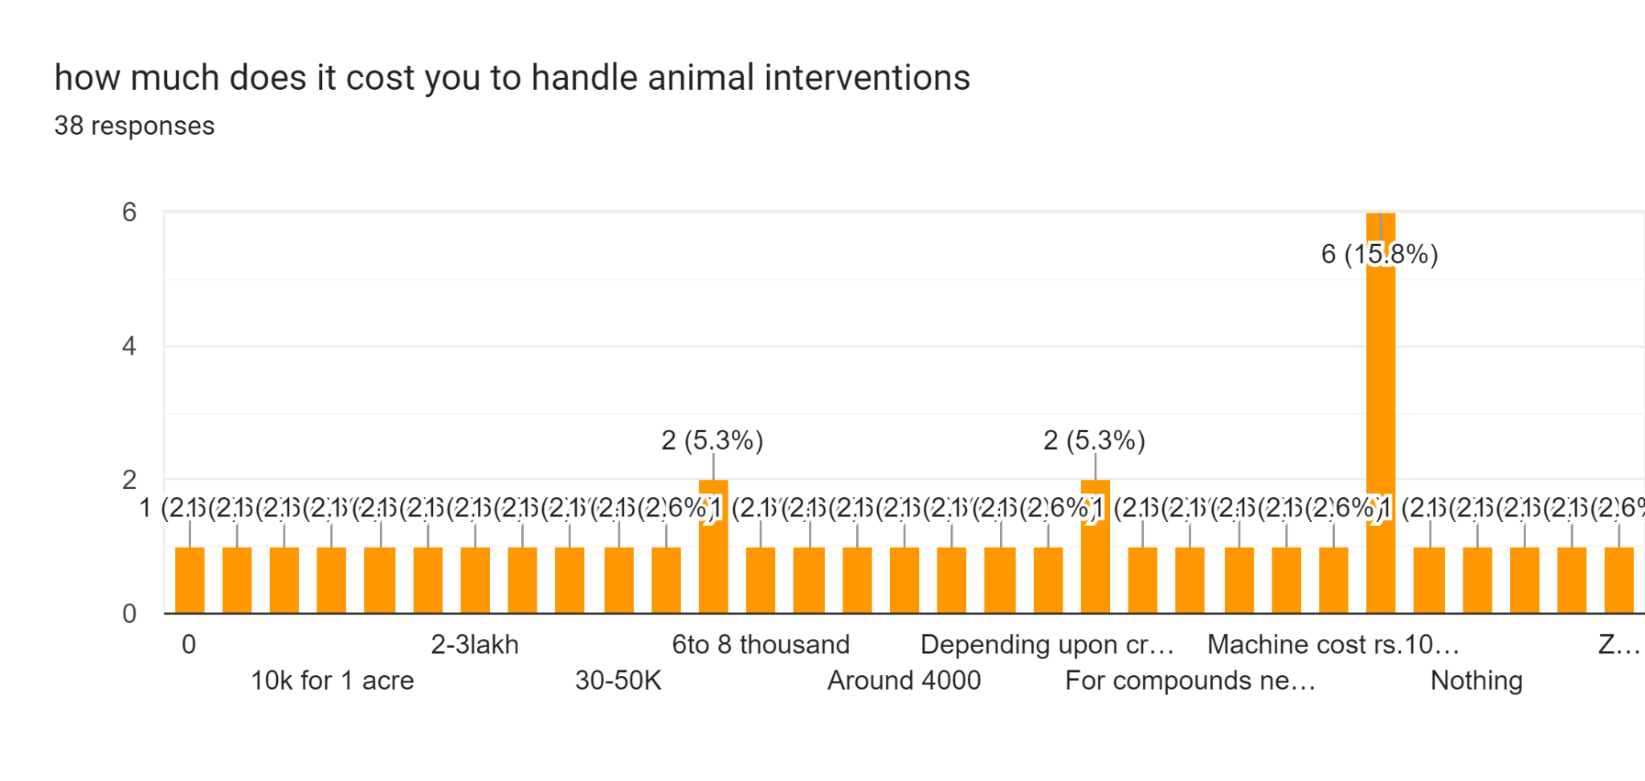

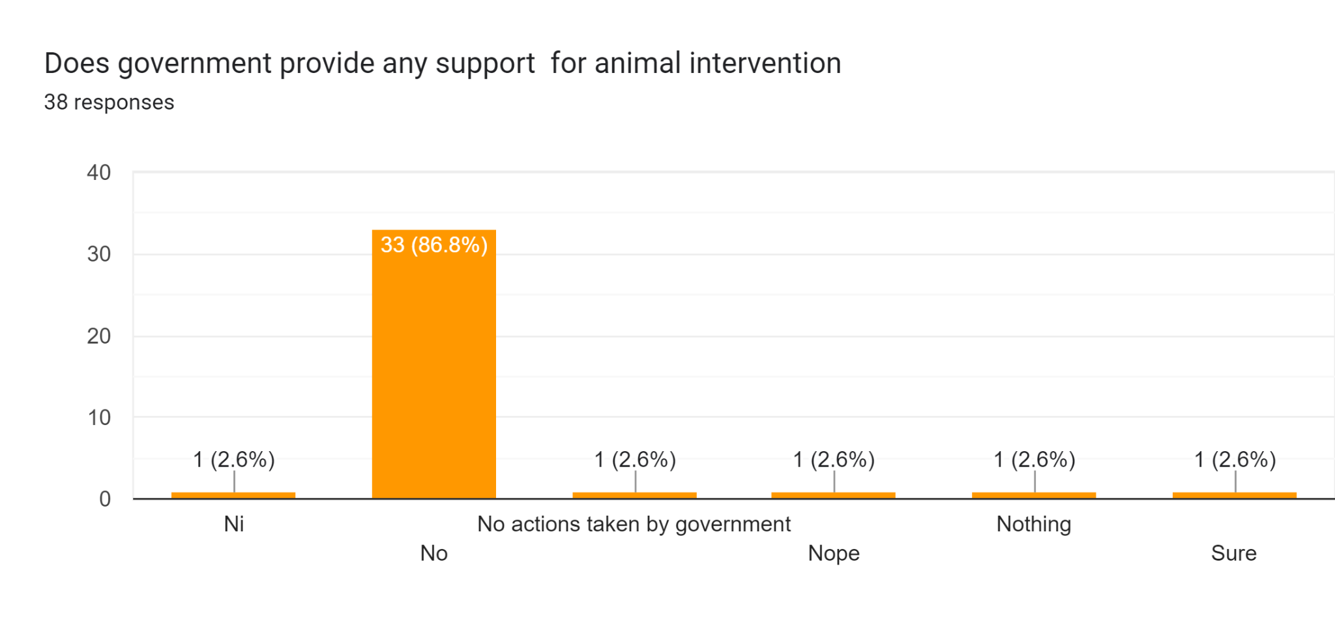

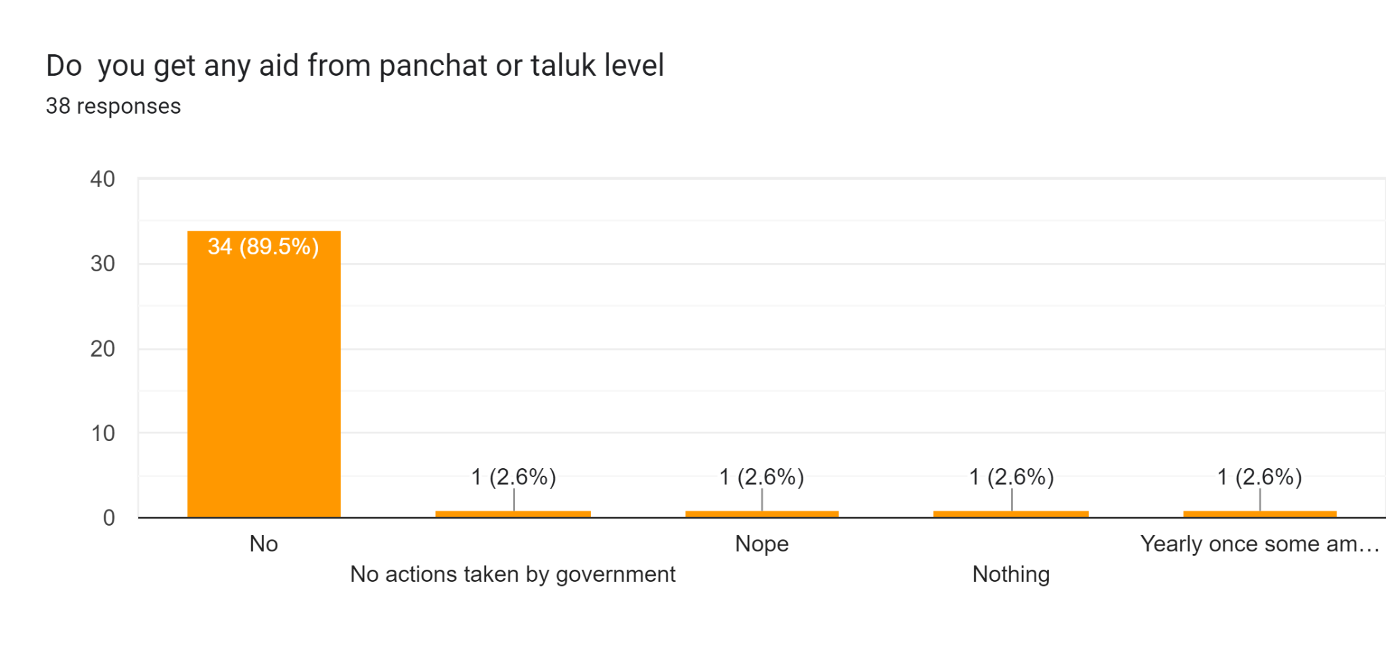

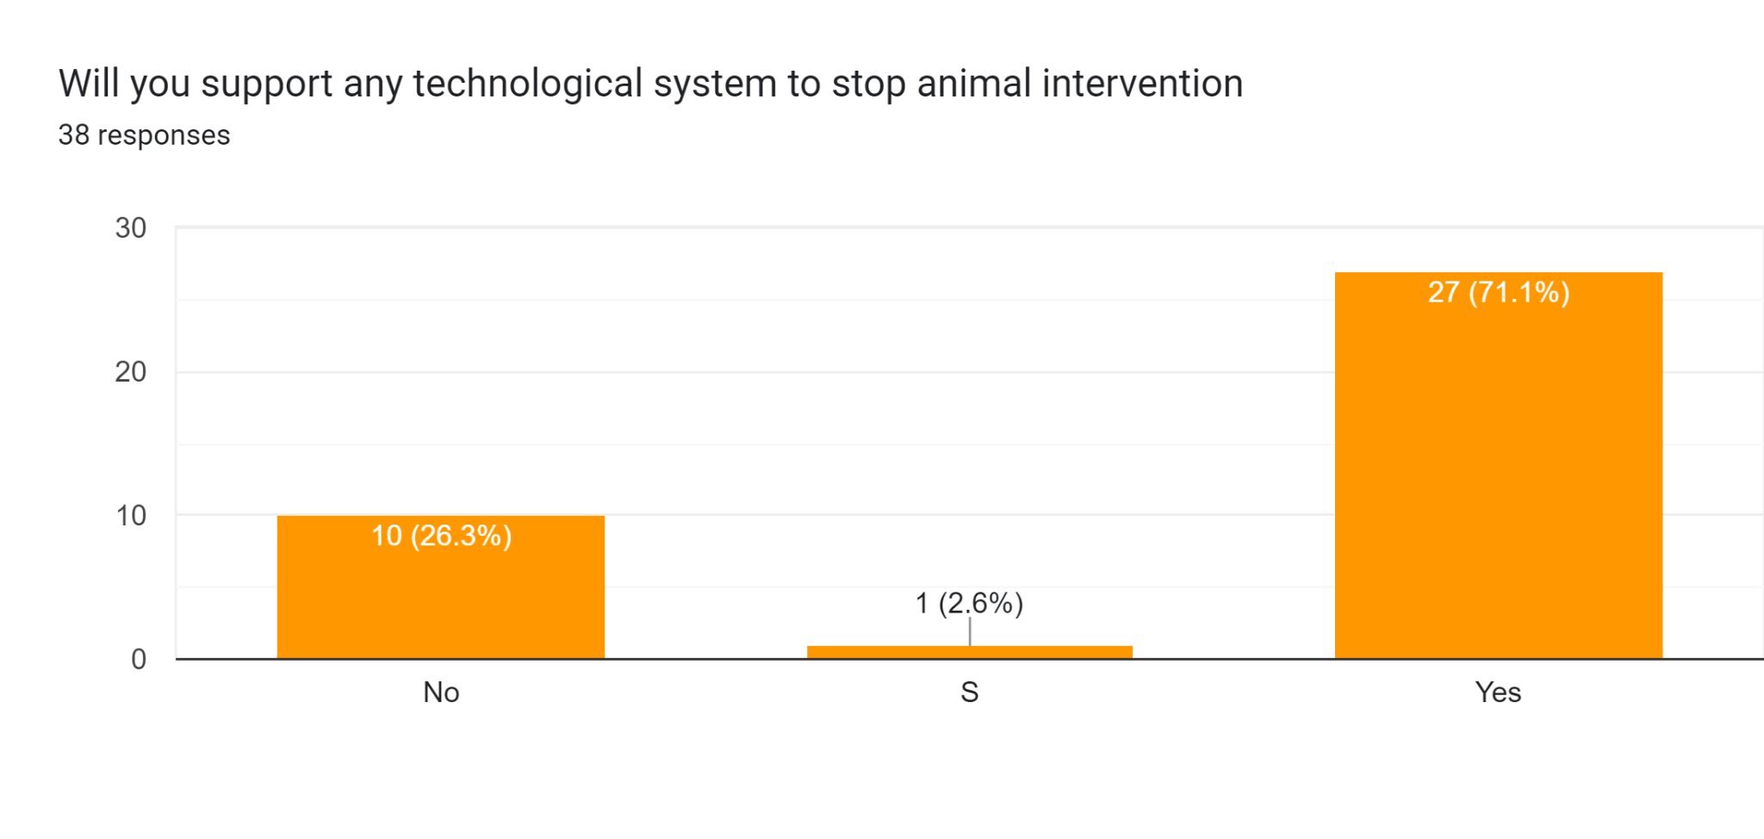

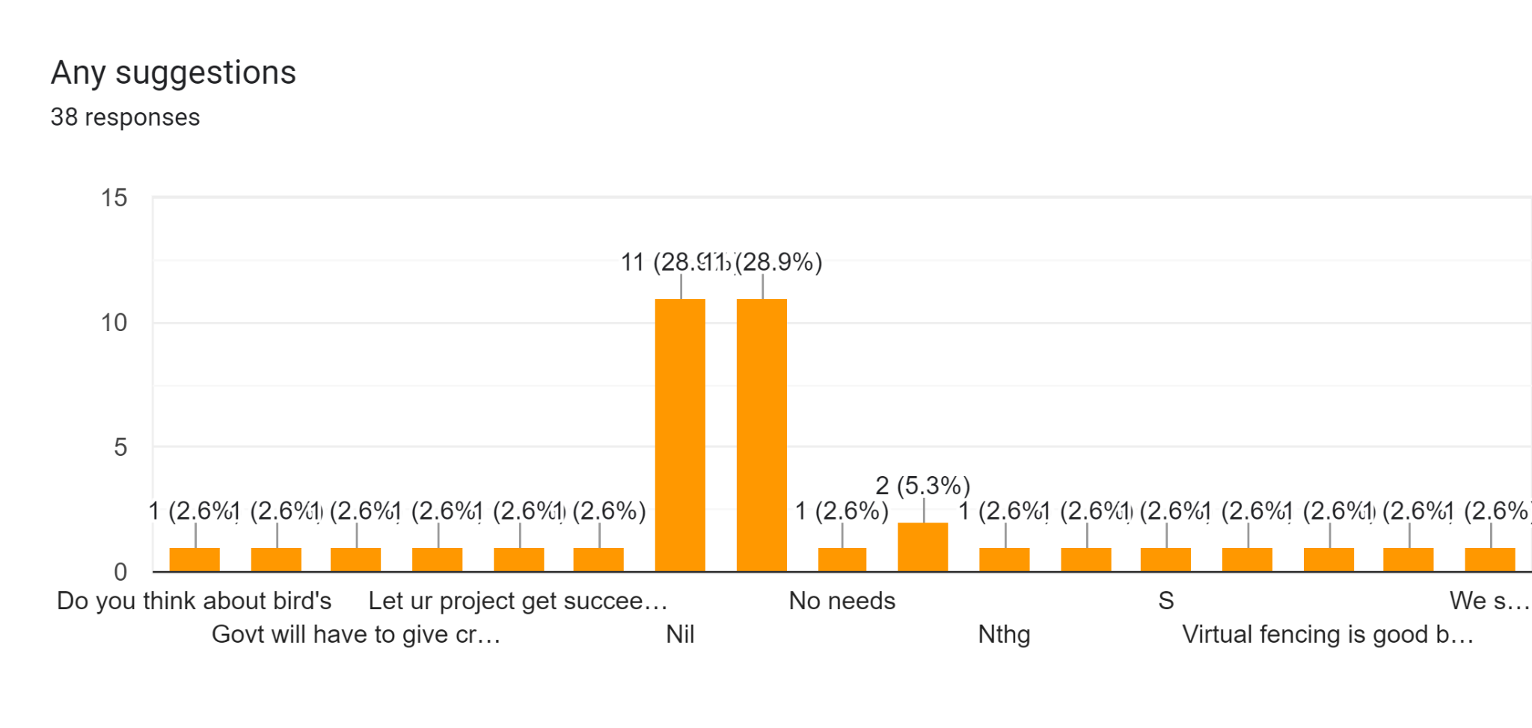

**REVIEW:**

→ The overall review of the survey, which was collected from the farmers, shows that they are facing challenges in preventing wild animals from entering agricultural land. Our team has collected 38 responses from farmers who are facing problems with wild animals, and we tried to collect them from the different places near the forest areas. We noticed that out of 38 responses from the farmers, the most frequently grown crops are vegetables [13.2%] and other monthly crops; they grow 6 to 4 times the same crops [39.47% farmers] within a year. In 38 responses we received, 94.4% of human or animal intervention happened, and the most attacked wild animals were bears [15.78%], deer, pigs [23.68%], monkeys [15.78% ], foxes, elephants, and many more. Most of the farmers are using recordings [28.9%] and some are staying near the land [13.2%] to handle the animal intervention. After using these methods, only 52.6% of farmers are able to stop animals, of which 47.4% are not able to stop animals from entering the lands. For handling these animals, interventions cost approximately more than 1,000 to 50,000 rupees, and it increases depending on the increase in their land. The government has provided the support for animal intervention, but which is not useful and only a small number of farmers are getting paid at the panchayat or taluk level. And farmers are willing to support technology [73.7%] in stopping animal intervention, but they still have no choice in stopping animals from entering agricultural land.